**Chapter I**

**Introduction**

In this present day where technology becomes complex and advance it is evident that most of the people, who have the capability, rely on it. Through, this they were able to perform their daily activities and productive.

The Carlos Hilado Memorial State College – Binalbagan Campus Administration office uses manual process in receiving some documents and scheduling the service vehicle of the school using Microsoft Excel. Through, this the assigned personnel can manage his/her time and makes his/her work easier and faster.

According to the assigned personnel in executive office of Carlos Hilado Memorial State College – Binalbagan Campus, recording documents, scheduling a service vehicle and blasting a message is very important because it serve as the basis for gathering reports.

The developers of this study tend to provide a system that will help the staff in managing their work. With the help of this system, the difficulty in finding the documents will not be the problem anymore as well as it lessens the workload of the administration personnel.

The developer also tend to provide a system that will help them manage scheduling the service vehicles of the school and providing a faster and easier way of informing them through text messaging and giving them more secure database than the current system their using.

**General Objectives**

The objective of this study is to develop a system that will provide convenience to the personnel and improve the administration office of Carlos Hilado Memorial State College – Binalbagan.

**Specific Objectives**

The specific objectives of this study are the following:

1. To upgrade and improve the current manual process of the administration office.
2. To secure all the files and documents stored in the database.
3. To give them exact output of reports.

**Purpose and Description**

Administration Management System is the process of creating information systems and supervising its flow from and to other organization. It also helps organized and control the flow of documents that you’ll receive. It is also the easiest way in requesting for a reservation for service vehicle. It allows the user to manage the task easily and make reports on daily basis of different tasks. This system can also determine what kind of documents is coming in. The Administration office needs a recording system to be easier for them to encode and classify the files.

The purpose of this study is to upgrade the manual process of scheduling and receiving the files or documents and to be easily informing the teachers, students, and staffs that there is an important announcement.

**Scope and Limitations**

The proposed system Carlos Hilado Memorial State College - Binalbagan Administration Management System limited on receiving documents only, informing some matter through text blasts and scheduling the service vehicle of Carlos Hilado Memorial State College- Binalbagan Campus.

This study is intended only for Carlos Hilado Memorial State College – Binalbagan Campus for minimizing the work load and to be easily process the documents.

**Significance of the Study**

This study is significant and beneficial to the following:

***Faculty/Staff/ Employees.*** It is easy to inform if there is an important announcement.

***Administration.*** Help them secure and manage the files and provide them the fastest and easiest way of announcing important information.

***Student.*** Can help them know the basic information in the school.

***School.*** This system is suited for it is related to the administration office.

***Assigned Personnel.*** The work will be easier, faster, efficient and effective.

***Researchers.*** Use the cited references and relate to the proposed system and improve the current system.

***Future Researchers.*** For the future researchers, this system can benefit the next generations and help them develop their works especially in getting some related study.

**Definition of Terms**

For the clarification of the common understanding, the key word has been used in this study will be defined as follow.

***Administration*** – is the range of activities and supervising the way that an organization or institution function. (Collins Dictionary)

In this study, the term was used as the one that is capable in announcing some information and monitoring the incoming files.

***Blast*** – to destroy, break apart, or remove with an explosive. (Merriam Webster Dictionary)

In this study, the term was used to describe a SMS text messages that is sent to multiple phone numbers utilizing an automated messaging system.

***Management*** – the act or skill of controlling and making decisions about a business, department, sports team, etc. (Merriam Webster Dictionary)

In this study, the term was used to organize or arranging the files properly.

***Reservation*** – an arrangement to have something held for your use at a later time. (Merriam Webster Dictionary)

In this study, the term was used to store or retrieve information and conduct transactions.

***Text***– the original words of a piece of writing or a speech. (Merriam Webster Dictionary) In this study, the term was used as a human – readable sequence of characters and the words they form that can be encoded into computer – readable formats.

***System*** – is a way of working, organizing, or doing something which follows a fixed plan or set of rules. (Collins Dictionary)

In this study, the term was used to manage and provide services to other programs that can be run in the computer.

**Chapter II**

**Review of Related Literature and Systems**

This chapter presents the reviews of related works and studies that deals in scheduling, recorded documents and disseminating information. The scope of these concepts provides multiple articles from different sources to familiarize the needed data for the study.

**Related Concepts**

The proponents conduct a research with the use of internet and books to provide related literature and prior arts system that are applicable in the development of the system.

**Foreign Related Study**

This study discusses the foreign related studies.

**Facilities Reservation System**

Facilities Reservation System helped to improve the way we share ICT and other resources across the school community. Staff must view the availability of rooms and key pieces of equipment at a glance and book quickly. “Implementing a facility Reservation System in Banchory Academy”. Banchory Academy, Scotland.(Pinkman C.,2013)

This system is similar to the present study because this study aims to improve the manual process into computerized Facilities Reservation and to easily check for the availability of the facilities.

**Government Records Management**

While many authors have compiled guides and treatises on records management in general, employees of local governments such as countries and cities have a scarcity of sources to reference. Despite many local governments falling under the purview of their state archives or equivalent, specialized, practical guides in applying records management principles in today’s economic climate are crucial to the success of a local government’s records program. This thesis compares the writings of several authors on records management theory, including some writings specially tailored to local government records management. This comparison reveals similarities running throughout all the authors’ works, even in those from the beginnings of the field in the United States. The City of Bellingham, Washington is used as a case study to examine the situation of a local government’s records program under increasingly difficult operating restrictions. An overview of the different departments’ knowledge of records management requirements and existing recordkeeping practices reveals crucial areas that need to be addressed both for the City of Bellingham and in local government records management theory. (Katherine Magee, 2012)

This system is similar to the present study because the proponents aimed to help the government organized their records through this system and to easily find the recorded documents, and also for securing the records.

**Schedule System**

Homewood prioritizes the schedule system resource to be used as fully efficient as possible. The schedule system provides equitable access to a variety of rooms, time management and faculty information, as well as to provide the students to search more information on their own. (John Hopkins’s University S.Y. 2012-2013)

This study is similar to the proposed system because it aims to upgrade the scheduling system in John Hop kin’s University and to be easy to the students to search if there is a fair in scheduling a room.

**Scheduling Management System**

The Southern California Community College Long Beach City College has gone live with a Congo’s – based faculty and student scheduling management system that was designed by Irvine, CA- based professional services firm E2E Analytics, prior on installing the new system. LBCC which has two main campuses and multiple satellites that supports 9 schools and 34 departments. The schools scheduling management system budgeting and planning up three months to compile, consolidate, and implement. Updating and checking of faculty and students Information was inspired by the advancement of modern technology. The researchers gathered data necessary in the scheduling system for the success of the study providing benefit of the employees and students so they can have access and the ability to manage information directly and conveniently.(Southern California Community College ,2013).

This study is similar to the proposed system because they aimed to develop and manage their scheduling system and to make their work efficient and convenient to use.

**Event Notification System**

Carzaniga et al. (2014) conducted a research study to design and evaluate a Wide-

Area event notification service. At this study the researchers defined the eventsnotification service as:” an application-independent infrastructure that supports the construction of event-based systems, whereby generators of events publish event notifications to the infrastructure and consumers of events subscribe with the infrastructure to receive relevant notifications”. Researchers stated two primary services which should be provided to components by the infrastructure which are they: notification selection, they provide example for this type which is determining which notification match which subscription, and notification delivery which can be implemented by routing matching notification from publishers to subscribers.

This study is related to the current system because they aimed to develop the fastest way in notifying the students if there is an important announcement.

**Local Related Study**

This study discusses the local related studies.

**Automated Class Scheduling System**

The study tested the functionality of Automated Class Scheduling System in terms of speed, data handling, accuracy, security, and stability and adaptability in making class schedules. This study was conducted in Bohol Island State University Main Campus, Tagbilaran City during the second semester of school year 2010-2011. The respondents of this study were the 6 expert instructors in the field of computer programming. They tested and evaluated the functionality of the programs in terms of its design, accuracy, data handling, security, stability, and adaptability. (Mischel Guzman, 2010-2011)

This study is similar to the present study because it refers to the fastest way in scheduling classes and to easily know your class schedule through this system.

**Hotel Reservation System**

Description with UML Hotel Reservation System. Developed a hotel management system that can be used online. This system allows the guests to do their booking online by them self. Some of task that the system can do are providing a query for arriving date and the length of staying, providing the number of On rooms, view all available rooms and provides user the ability to choose one or more of them, recording the number of on rooms, view all available rooms and provides the user the ability to choose one or more of them, recording kind of guest sand how many going to be in the single room, providing the cost of booking, asking the users if they want additional service; such as, dinner or breakfast, storing the guests detail; like, name, address and telephone, asking the user for confirmation, final confirmation views with the detail of booking and the guests can review or cancel the booking. (Alfred Escopin, 2014)

This study is similar to the present system because it aimed to enhance and upgrade the hotel reservation system and to easily find or check for the available of rooms as well as for the safeties of the costumers.

**Membership Record Management System**

Record is “Information created, received and maintained as evidence and/ or information by an organization or person, in pursuance of legal obligations or in the transaction of business”. A record has to be retained as long as it has value and is destroyed at the end of that period. A document therefore, is everything else so “does a document really need to be stored at all?” Today with the advances in technology, churches have adopted to change and in certain circumstances are accepting emails and other electronic forms of documents or correspondences as ‘best evidence’ where bone-fide hard copy originals are not available. In the past when churches were looking for solutions to remove or reduce cost from their projects, their first port was to remove old files from their expensive office space and put it into deep storage in a remote warehouse where the price was low and access was minimal.( BS15489, 2012)

This study is similar to the present study because they aimed to manage their membership recording through developing this system to secure and easy to find the old documents when it is needed. Through this system the proponents tend to improve their membership record into a systematic way.

**Automated Record Management System**

The automated record management system is the arms that will hold the business in its goal to a paperless office environment. From the acronym itself, the ARMs is that management process that will protect information and data to ensure that all the records and the files in the system database of the business organization is protected and easily accessed by the users in the framework. (Castro, 2010)

This study is similar to the present study because they aimed to improve and develop their recorded files into computerized to properly manage their files. This study also refers to the safeties of the files.

**Integrated Class Scheduling System**

Philippines with an estimated annual population growth rate of 1.9 % is one of the fastest growing countries in Asia in terms of population and still expected to continue its growth for the next few years. These population increases will consequently demand access to higher education opportunities. As of Academic Year 2011-2012, Philippines have 2,299 public and private Higher Education Institutions (HEIs) including 110 state universities and colleges all over the country. Most of these SUCs are strategically located in the urban areas of different regions. However, growth on the main campuses or parent campuses may soon jeopardize their ability to fulfill their function as a state College or University. Thus the construction of satellite campuses appears to be the answer. Currently, there are 437 satellite or external campuses in the Philippines scattered within or beyond the locality. Satellite campuses definitely benefit the community. They target specific population areas normally underserved by main campuses. They allow more direct access to higher education for targeted populations. These branch campuses also serve as a benefit to the main campus. As students utilize services offered at branch campuses, congestion or overcrowding on the main campus decreases. This means an ease in parking situations as well as reduced traffic on campus roadways. Further, branch campuses reduce the commuting costs for faculty, staff and students. The closer the services, the less time spent on crowded roadways. Finally, the more sites opened to students, the more students would be given the chance to pursue and finish a professional degree. (National Statistics Office, 2011-2012)

This study is similar to the proposed system particularly in scheduling to be easily scheduled the class and to calculate the annual population growth. They tend to develop a system that will easily search for the scheduling of classes.

**Table of Comparison**

The table shows the list of the prior system both foreign and local system and different features that compare on the features of administration management system.

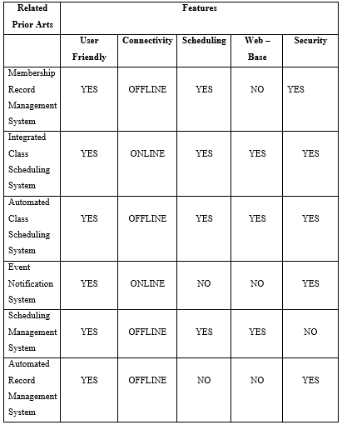*Table 1. CHMSC – Bin Administration Management System features Comparison Table of Related System*

Conclusion:

Table 1 shows the comparison of related system; this shows what are the existing systems that can be compare to develop the project. This includes their features such as connectivity and security.

**CHAPTER III**

**DESIGN AND METHODOLOGY**

This chapter presents the design and methodology of the proponent’s system.

**System Development Life Cycle**

The Software Development Life Cycle (SDLC) is a framework defining tasks performed at each step in the software development process. It is a structure followed by a development team with in the software organization. It consists of a detailed plan describing how to develop, maintain and replace the specific software. The life cycle defines the methodology for improving the quality of the software and over all development process. The proponents will use the Rational Unified Process Methodology as a guide of processing the system flow.

**RAPID APPLICATION DEVELOPMENT METHODOLOGY**

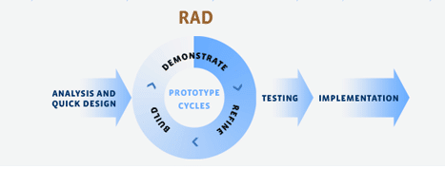

*Figure 1: Rapid Application Development Methodology*

Figure 1 shows the Rapid Application Development Methodology diagram illustrates the process to be able to have a high quality system. This method provides a plan to develop a system. This method start from initial planning where the proponents decide for the system to be made, evaluate the system requirements to able the system to be successful and usable. Analysis and design is where the proponents analyze if the system is compatible on the needs require by the client and if the system is ready for implementation where the system is settled for the testing and evaluation where the system will be used by the user to know if the is ok and if there is something to improved or change, and must continue the processes until the system reach the satisfaction of the client. The advantage of rational unified process methodology is it can provide the step by step process to reduce unnecessary developmental cost.

**Analysis and Quick Design**

In this phase, the proponents analyzed the data they gathered and created a design that is suitable for the processed for Carlos Hilado Memorial State College Binalbagan Campus administration.

**Demonstrate**

The proponents will make it sure that the system is well-establish and runnable.

**Refine**

In this phase, the proponents will upgrade the system of Carlos Hilado Memorial State College – Binalbagan Campus Administration Office.

**Build**

The proponents develop a system that can help in order to improve the management of Carlos Hilado Memorial State Colleg – Binalbagan Administration Office.

**Testing and Implementation**

The proponents will make it sure that the system function is reliable and ready to use. The proponents shall conduct a system testing to the end user to be able to suggest the requirements that is need to the system. The proponents shall conduct a system testing to the administration and asked more suggestions if something must be changed. The system is only implemented to the Carlos Hilado Memorial State College Binalbagan Campus administration.

**Context Diagram**

*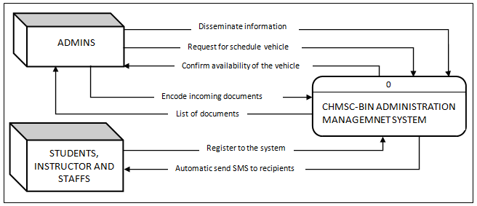Figure 2. Context Diagram of CHMSC –Bin Administration Management System*

Figure 2 shows the general process of the developed system. It also demonstrates the input requirements needed to be filled – up by the admin and the expected process output from the system.

**Data Flow Diagram**

The data flow diagram illustrates the flow of data, input requirements and process output of the developed system.

*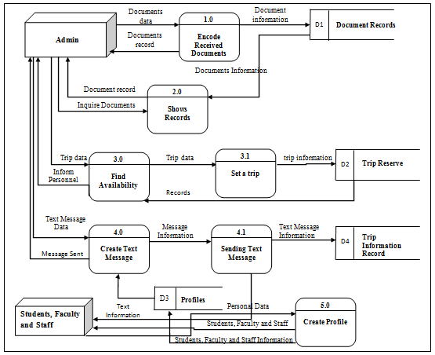Figure 3. Data Flow Diagram of CHMSC –Bin Administration Management System*

Figure 3 shows the entire data flow, the process the input requirements; process outputs and the storage of develop system.

**Use Case Diagram**

The use case diagram shows the user’s interaction with the system and its relationship between different use cases and the user is involved.

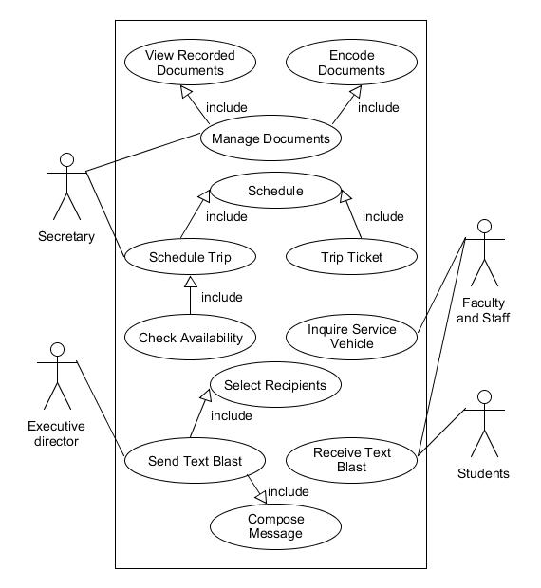

*Figure 4. Use Case Diagram of the Proponents Developed System*

**Use Case Description**

The table below describes the function, condition and alternative flows to be met of the actors in the use case diagram.

|  |  |
| --- | --- |
| **Use Case Name:** | **Text Blast** |
| **Actors:** | Executive Director, Dean, Students, Faculty and Staff, organization |
| **Description:** | This use case describes on how the admin inform the user. |
| **Pre-conditions:** | The Executive Director and Dean choose recipients. |
| **Post- conditions:** | The text message is successfully delivered. |
| **Normal Flows:** | 1. The executive director and dean choose recipients. 2. The executive director and dean type messages. 3. The executive director and dean disseminate information. 4. The students, organization, faculty and staff receive the text messages. |
| **Alternative Flows:** | 3. The admin must resend the text message. |
| **Business Rules:** | The information successfully blast. |

*Table 3. Text Blast*

|  |  |
| --- | --- |
| **Use Case Name:** | **Receive Incoming Documents** |
| **Actors:** | Secretary |
| **Description:** | This use case describes what type of documents is incoming. |
| **Pre-conditions:** | The assigned person verifies the documents if it is acceptable or denied and if it can be disseminate or not. |
| **Post- conditions:** | The assigned personnel will record it if it is accepted and if it is denied it will return to the sender. |
| **Normal Flows:** | 1. The secretary checked what type of documents is in coming. 2. The secretary decides if it is accepted or deny. 3. If accepted the secretary will record or encode the control number of documents in the system. 4. The secretary classifies and identifies the recorded documents and distributes to the other offices. 5. The secretary photocopies the documents as to the number of copies to be distributed. 6. The secretary disseminates the records to the concerned offices. |
| **Alternative Flows:** | 1. The secretary must recheck the documents. |
| **Business Rules:** | The secretary successfully encoded the received documents. |

*Table 4. Receive Incoming Documents*

|  |  |
| --- | --- |
| **Use Case Name:** | **Schedule or Reserved Service Vehicle** |
| **Actors:** | Assigned Personnel, Faculty and Staff |
| **Description:** | This use case describes on how to schedule a service vehicle of the school. |
| **Pre-conditions:** | The assigned personnel check if the service vehicle is available or not. |
| **Post- conditions:** | The assigned personnel will approach the staff and faculty that there is an available car.  The assigned personnel will reserve them a service vehicle and give them their date of travel. |
| **Normal Flows:** | 1. The faculty and staff inquire for the availability of service vehicle. 2. The secretary checked if the service vehicle is available. 3. The secretary gives the request form to the faculty and staff to reserve a car. 4. The secretary fills up the form and schedule the service vehicle. 5. The secretary booked the service vehicle for a purpose trip. 6. The secretary printed the trip ticket. 7. The secretary encoded the trip ticket number. 8. The secretary gives the trip ticket to the faculty and staff in charge. |
| **Alternative Flows:** | 5. The secretary must book the service vehicle again. |
| **Business Rules:** | The trip ticket is successfully hand-offs to the driver and team leader. |

*Table 5. Schedule or Reserved Service Vehicle*

**Activity Diagram**

The activity diagram shows the interactive flow of activities done by the actor of the developed system.

**Text Blast**

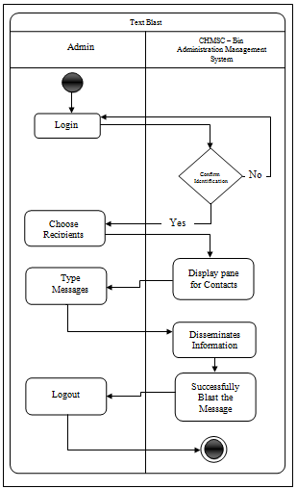*Figure 5. Text Blast Diagram of the Develop System*

Figure 5 shows the steps in notifying or blasting a message to the faculty and staff, students and all the organization inside the campus.

**Receive Incoming Documents**

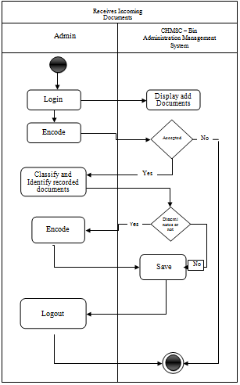*Figure 6. Receive Incoming Documents of the Develop system*

Figure 6 shows the process in receiving incoming documents.

**Schedule or Reserve Service Vehicle**

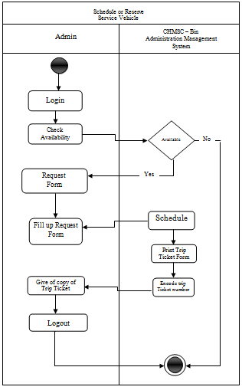*Figure 7. Scheduling of Service Vehicle of the Develop System*

Figure 7 shows the steps in reserving a service vehicle of the school campus.

**Decomposition Chart**

Decomposition Chart shows the break down process and its sub – processes of the whole system.

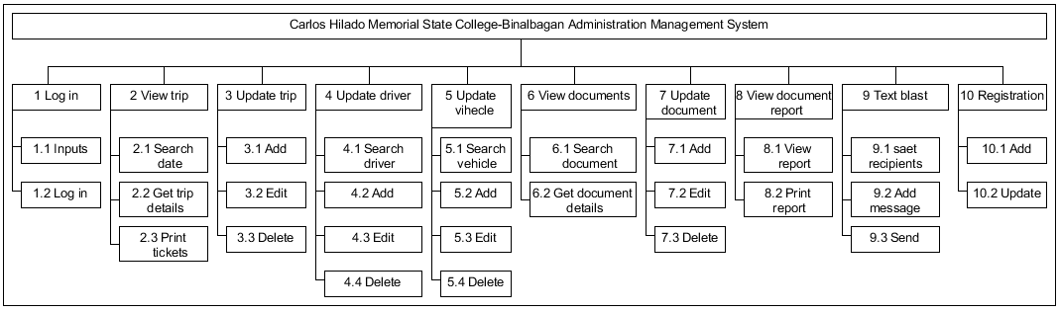

*Figure 8. Decomposition Chart of CHMSC – Bin Administration Management System*

Figure 8 shows the breakdown process and its sub – process of the develop system. Every process is been labeled and mark to equate the functionality of the whole system.

**Data Dictionary**

The table below shows the list of all tables and the data stored in the database on the CHMSC – Bin Administration Management System. It provides the attribute, data types and also the description for each fieldnames to recognize the data being in the database.

|  |  |  |  |
| --- | --- | --- | --- |
| **Fieldname** | **Description** | **Type** | **Length** |
| in_id | Log in identification | INT | 5 |
| in_admin | Admin user name | VARCHAR | 50 |
| in_pass | Admin password | VARCHAR | 50 |
| Type | Admin type | INT | 1 |

Table 6. login

|  |  |  |  |
| --- | --- | --- | --- |
| **Fieldname** | **Description** | **Type** | **Length** |
| d_id | Driver identification | INT | 10 |
| Fname | Driver’s first name | VARCHAR | 50 |
| Mname | Driver’s middle name | VARCHAR | 50 |
| Lname | Driver’s last name | VARCHAR | 50 |
| licence_no | License number | VARCHAR | 50 |
| Bday | Birthday | DATE |  |
| Address | Address | VARCHAR | 500 |
| Cellnumber | Cellphone number | INT | 15 |

Table 7. driver

|  |  |  |  |
| --- | --- | --- | --- |
| Fieldname | Description | Type | Length |
| v_id | Vehicle identification | INT | 10 |
| plate_no | Plate number | VARCHAR | 50 |
| v_type | Type | VARCHAR | 50 |

Table 8. vehicle

|  |  |  |  |
| --- | --- | --- | --- |
| **Fieldname** | **Description** | **Type** | **Length** |
| trip_id | trip identification | INT | 10 |
| Depardate | Departure date | DATE |  |
| Arrivedate | Arrival date | DATE |  |
| Purpose | Purpose | WARCHAR | 500 |
| Destination | Destination | VARCHAR | 500 |
| ve_id | Vehicle identification | INT | 10 |
| driver_id | Driver identification | INT | 10 |
| pass_no | Passenger identification | INT | 10 |
| Teamleader | Team leader | VARCHAR | 50 |

Table 9. tripsched

|  |  |  |  |
| --- | --- | --- | --- |
| **Fieldname** | **Description** | **Type** | **Length** |
| pass_id | passenger identification | INT | 10 |
| Fname | First name | VARCHAR | 50 |
| Mname | Middle name | VARCHAR | 50 |
| Lname | Last name | VARCHAR | 50 |

Table 10. trippass

|  |  |  |  |
| --- | --- | --- | --- |
| **Fieldname** | **Description** | **Type** | **Length** |
| Cntrl | Document identification | INT | 10 |
| Docfrom | From | VARCHAR | 50 |
| Doctype | Document type | VARCHAR | 50 |
| Docabot | Document arrive | DATE |  |
| Dessi | Date of dissemination | DATE |  |
| Disseto | Subject of dissemination | VARCHAR | 50 |
| Subid | Status | CHAR | 5 |

Table 11. redoc1

|  |  |  |  |
| --- | --- | --- | --- |
| **Fieldname** | **Description** | **Type** | **Length** |
| Dcntrl | Document identification | INT | 10 |
| Ddocfrom | From | VARCHAR | 50 |
| Ddoctype | Document type | VARCHAR | 50 |
| Ddocabot | Date | DATE |  |

Table 12. redoc2

|  |  |  |  |
| --- | --- | --- | --- |
| **Fieldname** | **Description** | **Type** | **Length** |
| Stuid | Student identification | INT | 10 |
| Fname | First name | VARCHAR | 50 |
| Mname | Middle name | VARCHAR | 50 |
| Lname | Last name | VARCHAR | 50 |
| Course | Course | VARCHAR | 50 |
| Year | Year | VARCHAR | 50 |
| Section | Section | VARCHAR | 50 |
| Cpno | Cellphone number | VARCHAR | 50 |
| Status | Status | VARCHAR | 50 |

Table 13. student

|  |  |  |  |
| --- | --- | --- | --- |
| **Fieldname** | **Description** | **Type** | **Length** |
| Insid | Student identification | INT | 10 |
| Fname | First name | VARCHAR | 50 |
| Mname | Middle name | VARCHAR | 50 |
| Lname | Last name | VARCHAR | 50 |
| Department | Course | VARCHAR | 50 |
| Status | Year | VARCHAR | 50 |
| Inslevel | Section | VARCHAR | 50 |
| Cpno | Cellphone number | VARCHAR | 50 |

Table 14. instructor

|  |  |  |  |
| --- | --- | --- | --- |
| **Fieldname** | **Description** | **Type** | **Length** |
| Staid | Student identification | INT | 10 |
| Fname | First name | VARCHAR | 50 |
| Mname | Middle name | VARCHAR | 50 |
| Lname | Last name | VARCHAR | 50 |
| Cpno | Cellphone number | VARCHAR | 50 |

Table 15. staff

|  |  |  |  |
| --- | --- | --- | --- |
| **Fieldname** | **Description** | **Type** | **Length** |
| Orgid | organization identification | INT | 10 |
| Name | Name | VARCHAR | 50 |

Table 16. organization

|  |  |  |  |
| --- | --- | --- | --- |
| **Fieldname** | **Description** | **Type** | **Length** |
| spo_id | stu_position_orgidentification | INT | 10 |
| Position | Position | VARCHAR | 50 |
| student_id | Student | INT | 10 |
| organization_id | Organization | INT | 10 |

Table 17. stu_position_org

**Architectural Diagram Interface of Hardware**

Shows the connection of the hardware that is needed to complete the system process including the data base to save data.



Android Phone

Internet

Database

Administration

*Figure10: Architectural Diagram of Administration Management System*

The Architectural Diagram of Administration Management System with the sub-system includes; Text Brigade, car reservation, and recording of incoming documents, illustrates the process of the system that the students are need to register their numbers. The administration can use the printer to print the trip ticket used for car reservation system. The information displayed on the monitor or screen also considered as output.

**System Testing and Implementation**

To ensure the system function and ready to use, the proponents will conduct a system testing to the end user to be able to suggest the requirements that the cooperative needs. The proponents conduct a system testing to the administrator of the cooperative and asked for more suggestions if something must be changed. The system is only implemented for the process undergoes on the Administration Management System.

**Hardware Specification**

For the development and runnable functions of the Administration Management System the user must have the following recommended hardware:

**For development:**

Monitor

Keyboard

Mouse

64 bit processor

Android (Android 4.0 or higher)

**Software Specification**

**For development:**

Heidi SQL version 8.3

Java (Neat Beans) version 8.2

Xampp version 3.2.2

Windows 7 and higher

**Gantt Chart**

The Gantt Chart assesses the proponents with the project management throughout the whole Process. It caters of how long the process will take that allow time management effectively. The minimum delivery time of this project was being figure out means of Gantt chart.

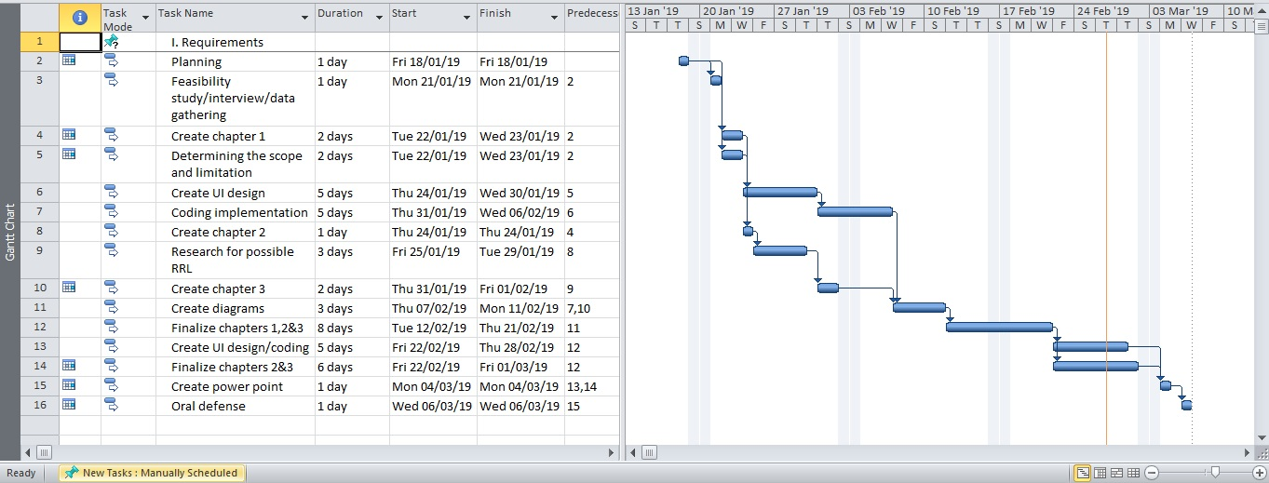

*Figure 11. Gantt chart Diagram*

Figure 11 shows the breakdown process of the given task to accomplish the study.

**Time Table**

|  |  |  |  |
| --- | --- | --- | --- |
| Task | Date started | Date finish | Assigned member |
| Planning | 18/01/19 | 18/01/9 | Catacata, Genilsa, Salibio |
| Feasibility study/interview/data gathering | 21/01/19 | 21/0119 | Catacata, Genilsa, Salibio |
| Create chapter 1 | 22/01/19 | 23/01/19 | Catacata, Genilsa, Salibio |
| Determining the scope and limitation | 22/01/19 | 23/01/19 | Catacata, Genilsa, Salibio |
| Create UI design | 24/01/19 | 30/01/19 | Catacata, Genilsa, Salibio |
| Coding implementation | 31/01/19 | 06/02/19 | Catacata, Genilsa, Salibio |
| Create chapter 2 | 24/01/19 | 24/01/19 | Catacata, Genilsa, Salibio |
| Research for possible RRL | 25/01/19 | 29/01/19 | Catacata, Genilsa, Salibio |
| Create chapter 3 | 31/01/19 | 01/02/19 | Catacata, Genilsa, Salibio |
| Create diagrams | 07/02/19 | 11/02/19 | Catacata, Genilsa, Salibio |
| Finalize chapters 1,2&3 | 12/02/19 | 21/02/19 | Catacata, Genilsa, Salibio |
| Create UI design/coding | 22/02/19 | 28/02/19 | Catacata, Genilsa, Salibio |
| Finalize chapters 2&3 | 22/02/19 | 01/03/19 | Catacata, Genilsa, Salibio |
| Create power point | 04/03/19 | 04/0/19 | Catacata, Genilsa, Salibio |
| Oral defense | 06/03/19 | 06/03/9 | Catacata, Genilsa, Salibio |

*Table 18. Task taken by the Proponents*

The table 18 shows the time duration of the given task for every proponent to accomplish the study.